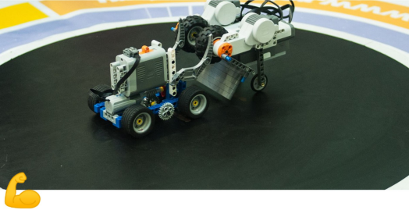
AUTONOMOUS SUMO

1. General provisions
A match is held between two teams. Each team enters one robot.
1.1 Competition task
The robot must push the opponent out of the ring. The match continues until one team scores the required number of points.
1.2 Restrictions
Unless otherwise specified by the organizers:
• A team may consist of up to 2 participants (number of supervisors is not limited).
• The oldest participant must be 15 years old or younger in the year of the competition.
Additional requirements may be set depending on the educational, age, or technical category of the competition.

2. Robot requirements
The robot must meet the following requirements:
• height – not limited
• width – max 150 mm
• length – max 150 mm
• weight – max 750 g

After the start and during the round:
• width – max 200 mm
• length – max 200 mm

Mechanical constructions that allow the robot to escape from the attack line after flipping are not allowed.

If parts with total mass exceeding 2% of the maximum robot weight detach during the match, the round is awarded to the opponent.
The robot must be fully autonomous. Any remote control is prohibited.
The control program must be written by the participants.

The robot must NOT use:
• devices that interfere with opponent sensors (for example IR LEDs)
• devices that disable opponent electronics
• devices that release liquids, powder or gas
• devices that throw objects
• sticky materials to increase traction
• suction or magnetic devices increasing downward force
Robot wheels or parts touching the ring must not be able to lift and hold an A4 sheet (80 g/m²) for more than 2 seconds.
Robots must not damage the ring, other robots, or cause injuries. Sharp edges smaller than 0.1 mm radius are not allowed.

Between rounds teams may repair or adjust robots if the changes do not violate the rules.
3. Arena description
The arena consists of a flat surface with a ring in the center and free space around it.
The ring is a black disk with a white border around the edge. The border is part of the ring.
Ring specifications:
• diameter – 770 mm
• height – 15 mm
• border width – 25 mm
• free space outside the ring – at least 500 mm

4. Competition procedure
Before the competition all robots are inspected.
After the start signal robots must wait 3 seconds.
A round lasts up to 30 seconds or until one robot scores 1 point.

Group stage matches consist of 1 round.
Elimination stage matches consist of up to 3 rounds or until one robot scores 2 points.

Robots are placed opposite each other behind a measuring cube or ruler (150 mm) placed at the center of the ring.

Robots must move toward each other and stay in contact until the end of the fight.
If a robot leaves the attack line after contact, it loses the round.
A round may not be restarted more than 3 times.

5. Violations
If a participant commits two violations in a match, the opponent receives 1 point.
Violations include:
• requesting to stop the match without reason
• taking more than 30 seconds to prepare for the next round
• touching the robot or arena without judge permission

6. Scoring
1 point is awarded if:
• the opponent robot touches the area outside the ring
• the opponent robot cannot move
• when time expires, the robot closer to the center of the ring wins

7. Determining the winner
The robot that scores 1 point wins the round.
If time expires, the robot closer to the center wins.
The robot with the most points wins the match.
If scores are equal, an additional round is held.
If still tied, judges determine the winner based on strategy, aggression and activity.

