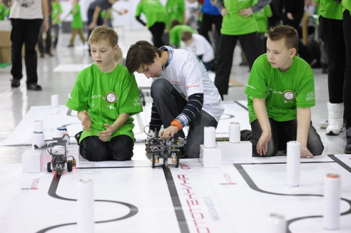

Speed Competition

Participation format
Each team consists of 1–2 participants.
Participants’ age: 7–12 years.

Competition rules
In this competition, teams must prepare a remotely controlled robot that can travel from the start zone to the finish zone along a path marked by posts (markers) as fast as possible.
The minimum possible completion time may be defined by the organizers before the competition starts.
The length of the robot is measured by the wheelbase.
During the competition, participants are not allowed to touch the robot.
All robots in the same race must be of the same type.

Competition track
The track size is 400 × 300 cm on a light-colored surface.
The track consists of a curved black line:
- line width — 10 mm
The robot must follow this line from the start to the finish.

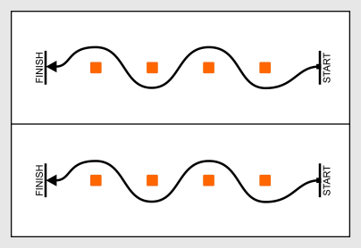

Robot requirements
- Robots must be built using robotics construction kits.
- Only one microcontroller may be used.
- The design may include sensors and motors.
- Robots must be fully assembled before the competition.
- Maximum robot dimensions: 29 × 20 × 20 cm.
- The robot must be remotely controlled.
- The robot must stop inside the finish area.
- Any robot that damages the competition field surface will be disqualified for the entire competition.

Competition procedure
- The competition consists of at least two attempts (exact number is decided by the organizers).
- Participants compete in pairs in elimination rounds.
- The maximum time for a run is determined by the organizers before the competition.
If time expires, the run is stopped and the robot closest to the finish wins.
- The track configuration remains the same for all robots within the same round.
- Before the first attempt and between attempts, teams may adjust their robots.
- Before each attempt, robots must be placed in the quarantine area.
After the judge confirms that the robot meets all requirements, the competition can begin.
If a violation is found during inspection, the team is given 5 minutes to fix the problem.
If the issue is not fixed in time, the team cannot participate.
After a robot is placed in quarantine, it cannot be modified (for example: uploading programs or changing batteries) until the attempt is finished.

Start of the race
At the beginning of the race, the robot must be placed in the start zone, positioned before the start line.
After the judge gives the start signal, the operator starts the robot.
Team members and supervisors must not interfere with the robot during the run.
Any interference results in immediate disqualification.

Race interruption
If during the race the robot:
- leaves the field
- moves uncontrollably
- cannot continue moving for 20 seconds
the run is stopped and the robot loses the race.
The robot must fully cross the finish line and stop behind it.
If the robot crosses the finish line but:
- does not stop
- leaves the field
- continues moving uncontrollably
the judges may stop the robot, and the organizers determine the winner.

Judging
- The organizing committee may change the rules, provided that the changes do not give an advantage to any team.
- The results are determined by the judging panel according to these rules.
- Judges have full authority during the competition, and all participants must follow their decisions.
- Judges may organize additional runs to resolve disputes.
If a team disagrees with a decision, it may submit an oral appeal to the organizing committee before the end of the current round.
A re-run may be allowed if the robot could not finish due to:
- external interference
- problems with the competition field
- a judging error.

