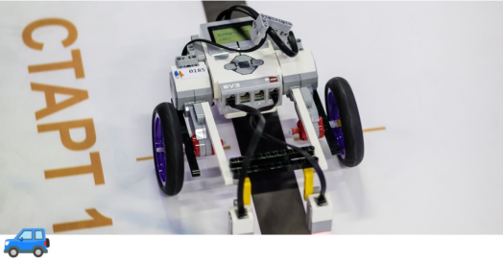

Line Following

1. General rules
Each team competes independently.
Each team may enter one robot.

1.1 Competition task
The robot must follow the line along the track and complete the course as fast as possible.

1.2 Restrictions
Unless otherwise specified by the event organizers:
- A team may have up to 2 participants (the number of supervisors is not limited).
- The oldest participant must be 15 years old or younger in the year of the competition.
Additional requirements may be set depending on the educational, age, or technical category of the competition.
If the category “Beginners” is used, the robot may use no more than 2 light sensors to detect the line.

2. Robot requirements
The robot must meet the following limits:
- length — max 20 cm
- width — max 20 cm
- weight — max 2 kg
The robot must not exceed these limits during the run.
The robot must be fully autonomous.
Any remote control is not allowed.
The control program must be written by the participants themselves.
The robot must be built from individual parts.
Pre-built robots with manufacturer-installed programs are not allowed.
The robot design must allow the start-finish system to detect it.
Robot wheels or other parts touching the field (when the robot is switched off) must not be able to lift and hold an A4 sheet of paper (80 g/m²) for more than 2 seconds.

3. Field description
The field is a flat white rectangular surface with a black line track.
It may be made from various materials, for example a printed banner (400–500 g/m²).

Start / Finish line
The start/finish line is a dashed line placed across the track.
It consists of two black strips:
- width — 10 mm
- length — 50–75 mm
The gap between them equals half of the maximum robot width.

Track parameters
- Track length — 11 m ±50 cm
- Line width — 20 mm
- Minimum curve radius — 50 mm
- Track shape — continuous with intersections
- Free space around the line — at least 300 mm on both sides
The exact track layout and field size are determined by the event organizers.
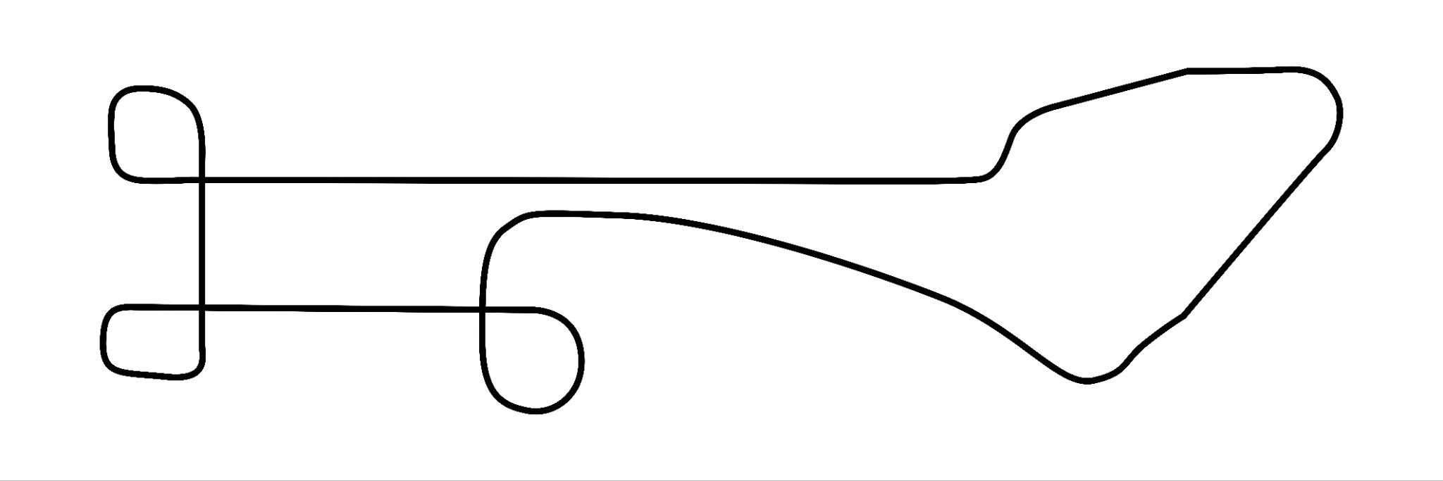
Example of the track

4. Competition procedure
Maximum run time: 2 minutes.
Before the run the robot must be placed in the start zone, and its projection must not extend outside this zone.
The robot starts and finishes in the start/finish zone.
Time may be measured by:
- the start-finish system
- or a judge with a stopwatch
The recorded time is final and cannot be changed.
Timing starts when the robot crosses the start line and ends when it crosses the finish line.
A robot is considered to cross the line when its projection crosses the line.
The number of attempts is determined by the organizers on the competition day.
The best attempt with the shortest time counts.

5. Disqualification
An attempt is disqualified if:
- the robot is remotely controlled
- the participant touches the robot or the field during the run
- the robot leaves the field
- the robot does not finish within the time limit
- the robot leaves the line for more than 5 seconds
- the robot leaves the line not tangentially
- the robot moves more than two robot lengths away from the line

6. Scoring
No points are calculated.

7. Determining the winner
The winner is the robot that completes the track in the shortest time.

