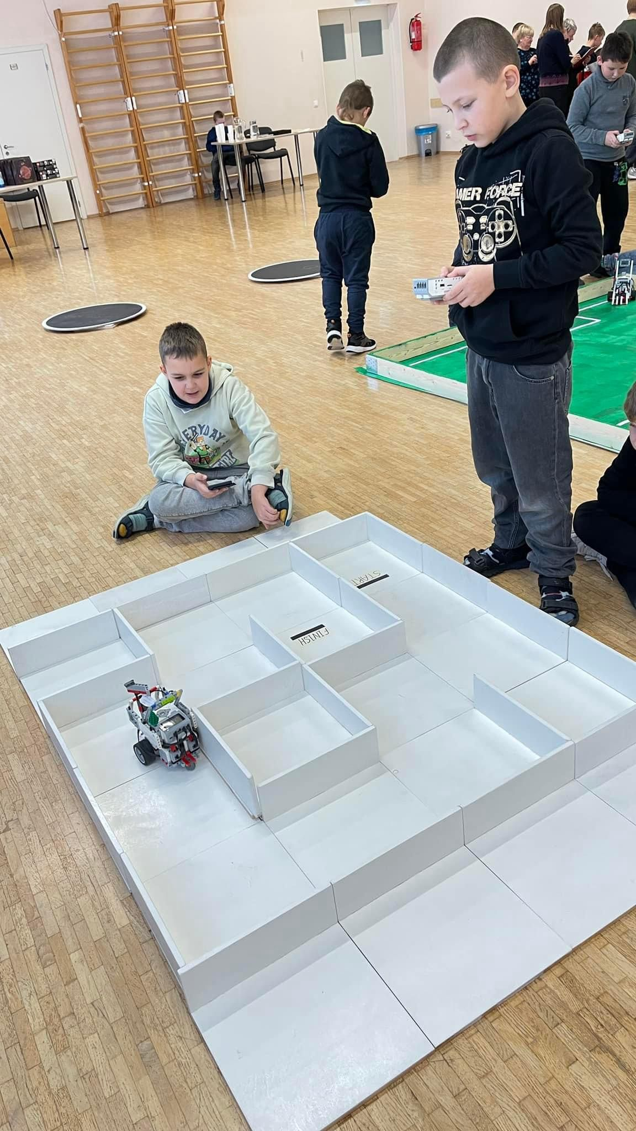
Maze (Autonomous)

1. Robot
The maximum size of the robot is 20 cm × 20 cm (width and length).
During movement the robot must not exceed these dimensions.
The robot must be fully autonomous (no remote control).
The maze may consist of several separate fields.
Each field has a flat horizontal floor and walls around the perimeter.
Fields may be connected to each other by openings or ramps.
The field is divided into cells of 30 ±2 cm.
Between cells there may be walls with:
- height at least 10 cm
- thickness 4–12 ±1 mm
Between walls there may be small gaps or protrusions up to 5 mm.
The floor may also have irregularities up to 2 mm.
The start cell and finish cell are marked with a black line.
The maze must be built so that there is only one possible path between any two cells.

2. Competition rules
The robot must travel from the start cell to the finish cell within 180 seconds.
Participants are given at least two attempts.
The exact number of attempts is determined by the judging panel on the competition day.
Before each attempt:
- the maze configuration
- the start cell
- the finish cell
may be changed.
However, the length of the shortest path (and, if possible, the longer path following the left-hand or right-hand rule) must be the same for all attempts.
Before the attempt and before any maze change, all robots are placed in quarantine.
The robot cannot move between two neighboring cells if there is a wall between them.
A robot is considered to leave a cell when no part of the robot remains inside that cell.
The lines marking the start and finish belong to those cells.
A robot is considered to enter a cell when it has completely left the previous one.
Time measurement starts when the robot leaves the start cell.

3. Stopping an attempt
The attempt is stopped if:
- the robot enters the finish cell
- the robot does not leave a cell for 30 seconds
- the participant asks to stop the attempt
- 180 seconds have passed
The result is recorded in the protocol.
The 30-second timer starts when judges detect that the robot has stopped moving.
If a participant touches the robot without judge permission, the attempt is stopped and the participant is disqualified.

4. Determining the winner
The result of an attempt is calculated as:
the number of cells remaining to the finish along the shortest path,
starting from the closest cell the robot reached.
The counted cells include the current cell but do not include the finish zone.
If two robots have the same result, the attempt time is used.
The winner is the robot that achieves the best result in the shortest time in its best attempt.

